MATLAB CODE AND RESULT:
Problem 1: Example of Nyquist bit rate calculation for a noiseless channel:
close all;
clc;
fs = 8000; % Sampling frequency
t = 0:1/fs:1-1/fs; % Time duration
cx = 1.1*sin(2*pi*100*t) + 1.3*cos(2*pi*300*t) + 1.5*sin(2*pi*2000*t);
bandwidth = obw(cx,fs); % Bandwidth of the signal
L=2; % Level of the signal
BitRate = 2*bandwidth*log2(L)

Output:
BitRate= 3.8019e+03
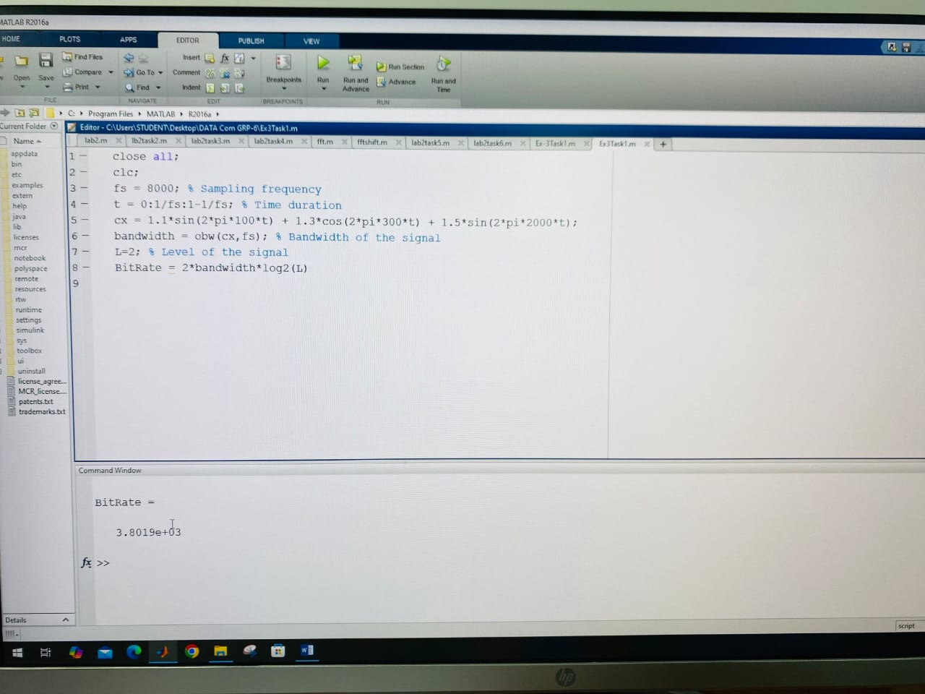

Problem2: Calculation of SNR
close all;
clc;
%Define number of samples to take
fs = 8000; % Sampling frequency
f = 400; %Hz
%Define signal
t = 0:1/fs:1-1/fs;
A = 3.0;
powfund = A^2/2
s = 0.1;
varnoise = s^2;
signal = A*sin(2*pi*f*t);
%noise
noise = s*randn(size(signal));
%noisy signal
noisySignal = signal + noise;

SNR = snr(noisySignal) %Calculation of SNR using snr function

defSNR = 10*log10(powfund/varnoise) %Calculation of SNR following the definition

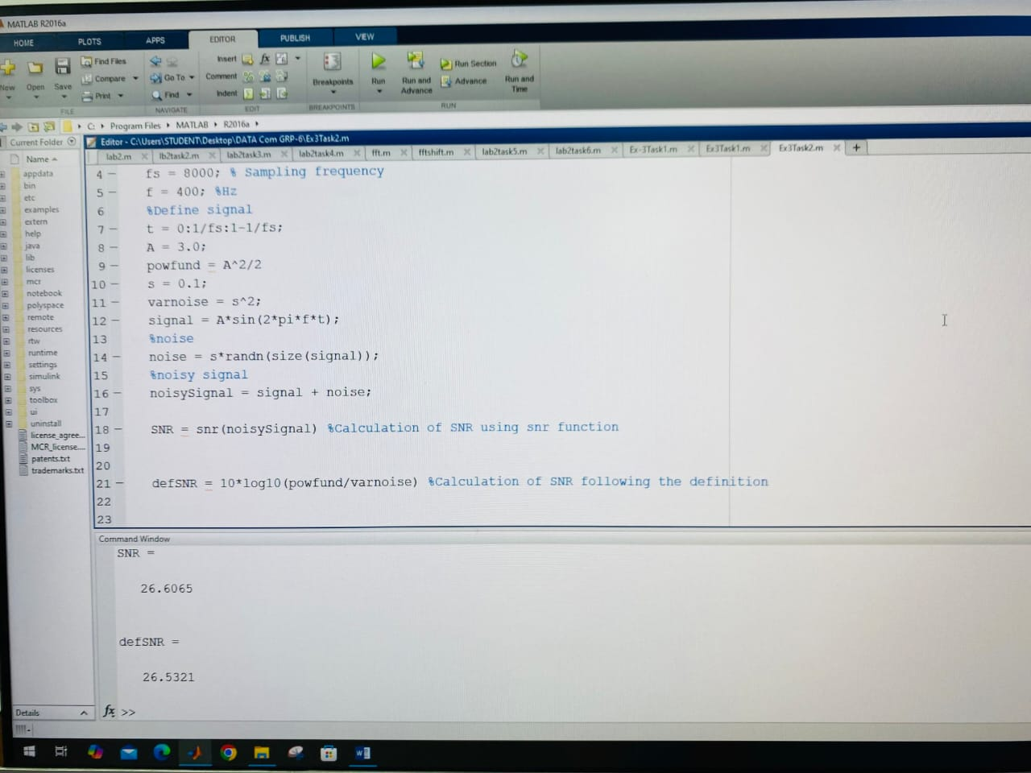

Task 1: Similar task can be done considering a noisy composite signal. Suppose our composite signal is, signal = 1.5*sin(2*pi*2*t)+0.9*cos(2*pi*10*t)+1.1*sin(2*pi*20*t) + 0.13*randn(size(t)); *****Calculate the SNR value of the signal.
Solution:
close all;
clc;
% Sampling frequency
fs = 8000;
% Time vector
t = 0:1/fs:1-1/fs;
% Signal parameters
A1 = 1.5; f1 = 2;
A2 = 0.9; f2 = 10;
A3 = 1.1; f3 = 20;
% Noise parameters
s = 0.13; % standard deviation of noise
varnoise = s^2; % noise variance
% Composite clean signal
signal = A1*sin(2*pi*f1*t) + A2*cos(2*pi*f2*t) + A3*sin(2*pi*f3*t);
% Add noise
noise = s * randn(size(signal));
noisySignal = signal + noise;
% Signal power (theoretical)
powfund = (A1^2 + A2^2 + A3^2) / 2;
% SNR using built-in function
SNR = snr(signal, noise);
% SNR using definition
defSNR = 10*log10(powfund / varnoise);
% Display output
disp(['SNR = ', num2str(SNR)]);
disp(['defSNR = ', num2str(defSNR)]);

Output:
SNR = 21.0835
defSNR = 21.0219
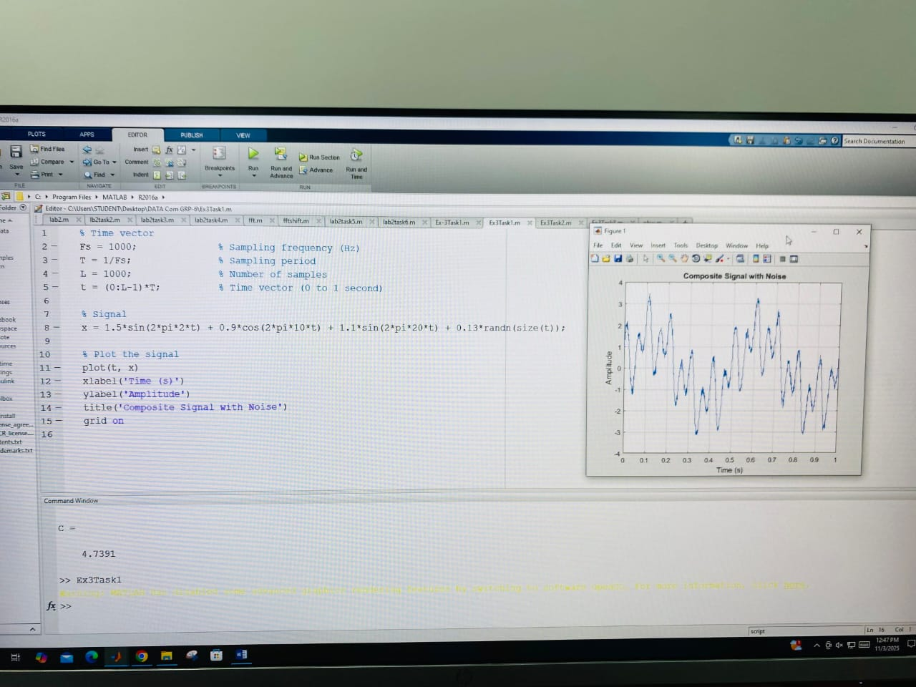
Problem3: Example of Shannon capacity calculation for a noisy channel:

clc
close all
fs = 8000; % Sampling frequency
f = 3; %Hz
%Define signal
t = 0:1/fs:1-1/fs;
A = 2;
s = 0.4;
%signal
x = A*sin(2*pi*f*t);
%noise
ns = s*randn(size(signal));
S_N_R = snr(x,ns);

bandwidth = obw(x,fs); % Bandwidth of the signal
%capacity
C = bandwidth*log2(1+SNR) % Capacity of the channel

Output:
